Ex.No:24: ATLAB SIMULATION OF PASSBAND TRANSMISSION WITH BER ANALYSIS UNDER MULTIPATH FADING CHANNELS
Objective 1:
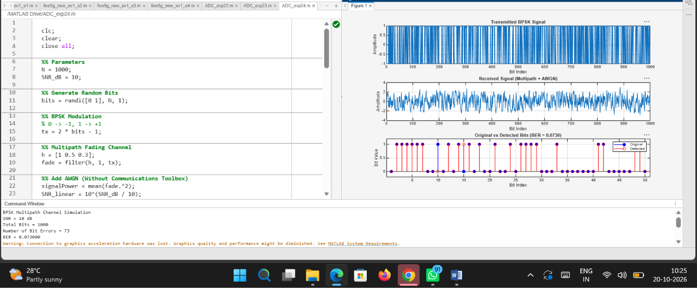
Code:

clc;
clear;
close all;

%% Parameters
N = 1000;
SNR_dB = 10;

%% Generate Random Bits
bits = randi([0 1], N, 1);

%% BPSK Modulation
% 0 -> -1, 1 -> +1
tx = 2 * bits - 1;

%% Multipath Fading Channel
h = [1 0.5 0.3];
fade = filter(h, 1, tx);

%% Add AWGN (Without Communications Toolbox)
signalPower = mean(fade.^2);
SNR_linear = 10^(SNR_dB / 10);
noisePower = signalPower / SNR_linear;

noise = sqrt(noisePower) * randn(N, 1);
rx = fade + noise;

%% Detection
bits_rx = double(rx > 0);

%% BER Calculation
numErrors = sum(bits ~= bits_rx);
BER = numErrors / N;

%% Display Results
fprintf('BPSK Multipath Channel Simulation\n');
fprintf('SNR = %d dB\n', SNR_dB);
fprintf('Total Bits = %d\n', N);
fprintf('Number of Bit Errors = %d\n', numErrors);
fprintf('BER = %.6f\n', BER);

%% Plots
figure;

subplot(3,1,1);
plot(tx);
title('Transmitted BPSK Signal');
xlabel('Bit Index');
ylabel('Amplitude');
grid on;

subplot(3,1,2);
plot(rx);
title('Received Signal (Multipath + AWGN)');
xlabel('Bit Index');
ylabel('Amplitude');
grid on;

subplot(3,1,3);
stem(1:50, bits(1:50), 'b', 'filled');
hold on;
stem(1:50, bits_rx(1:50), 'r');
title(['Original vs Detected Bits (BER = ' ...
num2str(BER, '%.4f') ')']);
xlabel('Bit Index');
ylabel('Bit Value');
legend('Original', 'Detected');
ylim([-0.2 1.2]);
grid on;
hold off;

Output:
